Prototype Design Specification

In order to define our prototype design specification an insight into how the initial GPS data is received will be first outlined. In a pilot project of the route #44 which travels the Havendale to Downtown route, five (5) buses were equipped with the Enfora GPS/GPRS Spider MTG-X units and tracking data collected by Clearchannel Communication. This company uses the GSM platform provided by Cable and Wireless Jamaica. Each GPS receiver is interfaced with a GSM\GPRS modem and placed on each bus. The GPS receiver and GSM\GPRS modem are powered by a 12 V dc battery pack. The GSM\GPRS modem uses the standard SIM card as in mobile phones. GPS receiver coupled with GSM\GPRS modem onboard the bus record point locations in latitude-longitude pairs, speeds of the bus, altitude, date, time and its validity at pre-specified time interval. The GPS receiver is designed in such way that it automatically sends this information as text of predefined format to the modem connected to it. GSM\GPRS modem, in turn, sends this text message in the form of SMS to the remote computer in the control room where it is stored in an excel file database.
Modeling GPS Unit over the Air Connection will involve creating NMEA codes
The Spider MTG-X allows a user to configure/setup the system parameters Over the Air (OTA). OTA configuration data is sent with UDP-API header. For the sending OTA commands to the Spider MTG-X. ). GPS message sent every 30 seconds. The Spider MTG-X has the ability to report GPS messages and events via UDP/IP packets to remote
servers. The MTG-X can report messages to a maximum of 10 server IP addresses. Event
messages can be acknowledged via a UDP command sent to the MTG-X to stop sending of the same message. The definition and use of the remote server reporting is detailed in Appendix A of this manual. The Spider MTG-X allows a user to read the device’s current GPS position NMEA messages.

The message output fields include the following parameters:

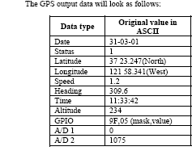

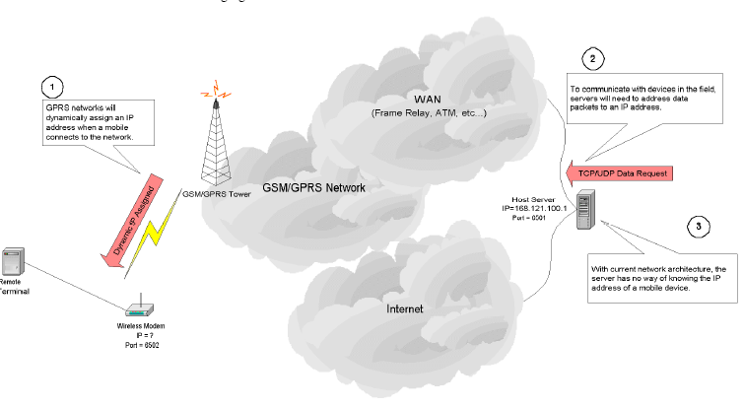

Therefore for our prototype design we’ll be using an approximate two month period of this recorded data. Consequently, this database will then act as an input to our software application. A sample message looks something like this
$GPRMC,172708,V,3606.2778,N,11956.1321,W,000.0,000.0,191200,015.0,E*75
It is at this point our prototype software application takes this raw data which consists of current time, latitude, longitude, altitude, heading, speed, GPS week, ID, etc. The current location of a transit vehicle can be calculated by latitude, longitude, and altitude. These values are straight from the GPS unit, in World Geodetic System 1984 (WGS84) decimal degree. Heading represents the direction that the transit vehicle is moving toward. Time means GPS Time-of-the-Week (TOW), which starts at midnight Sunday in UTC. CLASS DIAGRAMS
Bus Commuter
Name: String
Cell phone Number: String
Request Number: Integer
Bus Number: Integer
Bus Stop Number:
Integer
GPS Input

ETA Prediction

Nodes
Bus Stops

Route
Path

Buses

Dwell time is the time that a bus stays at a given bus stop once it has stopped there. This
time depends on the passenger demand, intersection signal, schedule adherence, and the
behavior of the bus driver
The transit schedule and the congestion for the weekday peak hour, the non-peak hour,
the evening, and the weekend period are different. TABLE A-1 through TABLE A-4 in
APPENDIX A list the predetermined schedule data by the time period. The four time
periods are weekend, weekday peak, weekday non-peak, and weekday evening. In this
research, weekday means Monday through Friday, and weekend means Saturday and
Sunday.

for the test bed 1 and the test bed 2, respectively. All data sets are clustered by time period, because transit vehicles have different schedules by time period, resulting in different travel patterns. The four time periods are weekend, weekday peak, weekday non-peak, and weekday evening. In this research, weekday means Monday through Friday, and weekend means Saturday and Sunday. Weekday peak period data included the bus data when the bus arrived at the first bus stop during 6:15 A.M. ~ 8:15 A.M. and 4:15 P.M. ~ 6:10 P.M. Weekday non-peak period data included the bus data when it arrived before 6:15 A.M., 8:15 A.M. ~ 4:15 P.M., and 6:10 P.M. ~ 7:15 P.M. Weekday evening period data include the bus data when the bus arrived after 7:15 P.M. These time periods were determined by the predetermined bus schedule shown in Appendix A. The bus location data have the current time at specific bus stops, and the time data determined by GPS unit were used to decide in which time period a bus is located. the number of observations for each time period. To calibrate and evaluate the prediction models (historical data model, multi linear regression models,

This data along with previously inputted historical data, dwelling time, traffic congestion is used to calculate the bus’s arrival time to every bus stop along its route. For more than one of the same bus on route, our application calculates the distance from the closest bus to every stop.

Algorithm for calculating bus arrival time

Start of Route Stop1 Stop2 Stop3 Stop4 End of Route
Stop 0 (lat_{b}, long_{b}) (lat_{c}, long_{c}) (lat_{d}, long_{d}) (lat_{e},long_{e}) Stop 5
(lat_{a}, long_{a}) (lat_{f}, long_{f})

Facts:
- The GPS system is calibrated to produce reading every 30 seconds.
- The variables that are obtained each 30 seconds from the GPS unit are listed as follows.
- The geographic coordinate of each bus stop is already known, represented by (X_{a-f},Y_{a-f}).
- The time to every bus stop on route is calculated, the instance the bus starts on its route.

GPS data: - Bus speed: Speed_{1-n}
Latitude: lat_{1-n}
Longitude: long_{1-n}
Time Stamp: Time_{1-n}
Bus ID: Bus_{1-n}
Route ID: Route_{1-n}

Where n is the last point on the route

Assumptions:

- The speed variations between each 30 second duration is negligible
- Since every route is not linear, a route is sub-divided into a series of straight line paths for
accurate analysis
- Each GPS co-ordinate has a plus/minus discrepancy

The Calculations
The approach:-
The distance between a stop and the bus’s present location is calculated for every instance.
Distance to a known stop requested (e.g. Stop 1, i.e. coordinates lat_{b}, long_{b}) is calculated.
Therefore for this example the bus starts at Stop 0. Based on the first reading obtained from the GPS units, the time to the other stops is calculated.

Therefore for every 30 seconds, a calculation is done:

Hence the first reading obtained from the GPS unit gives a (lat₁, long₁). Now we calculate the distance to the next bus stop (i.e. lat_{b}, long_{b}).

Exact distance in miles between this point & the first Stop 1(distance1):

distance₁= 3963 * arccos[sin(lat₁/57.2958) * sin(lat_{b}/57.2958) + cos(lat₁/57.2958) * cos(lat_{b}/57.2958) * cos(long_{b}/57.2958 – long₂/57.2958)]

……..

distance_{n}= 3963 * arccos[sin(lat₂/57.2958) * sin(lat_{b}/57.2958) + cos(lat₂/57.2958) * cos(lat_{b}/57.2958) * cos(long_{b}/57.2958 – long₂/57.2958)]

………………………………………………………
Aside
The above equation in Excel would be (ACOS(((SIN(A1*PI()/180))*(SIN(A2*PI()/180)))+((COS(A1*PI()/180))*(COS(A2*PI()/180))*(COS((ABS(B2-B1))*PI()/180))))*180/PI())*69
…………………………………………………………………………..

For the next reading from the GPS unit this algorithm is done again, so the new distance (distance2) would be (lat2, long2) and the first stop remains (latb, longb).
Each distance count down is tabulated/store/updated in our database.

Also since the speed is given with each coordinate, the average is found as the route progresses.

It should be noted that each route has historical data, based on previous calculations known for speed and time. Hence for every point already have 1 historical speed (Speed_{historical}) and 1 historical time (time_{historical})
Therefore when Speed₁ and Speed₂ is obtained, the average speed becomes:

Speed_{avg1} = Speed₁+Speed₂ + Speed_{historical1}
3
Speed_{avg2} = Speed_{avg1} +Speed₃ + Speed_{historicalavg1}
3

……

Speed_{avgn} = Speed_{avg(n-1)} + Speed_{(n+1)} + Speed_{historicalavg(n-1)}
3

Finally, since we have the continued distances (distance_{(1-n)}) and speeds (Speed_{(1-n)}) the corresponding times (time_{(1-n)}) to each stop is found by.

time₁ = distance₁
Speed_{avg1}

…………….

time_{n} = distance₂
Speed_{avgn}

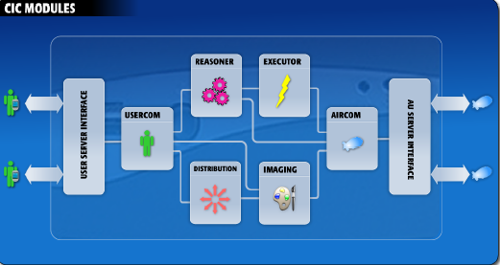

Additional Information:

Beginning from the user

The User Request: Bus Arrival

Step 1: User in Bus Stop # and Bus/Route #

Eg. Text 444 – Bus Stop 05 # Bus/Route 78 #
Or Text 444- 0578

The text queries the database at (Bus Centre) Time Prediction Program

The Time Prediction Program firstly retrieves the latest position of all Buses on route 44.
From this the distance between bus Stops and bus location are calculated.

These distance values are compared with each other from which the closet bus distance to the requested Bus stop is chosen.

When Closet Bus is Chosen the assigned latest Arrival Time is retrieved from tracking table

This value is output to the user via SMS or updated LED board

Ongoing calculations

As the speed is retrieved the average speed is constantly calculated. At the time of request the current average speed is used. It is added to the average historical speed (depending on the time of day)

time₁ = distance₁
Speed_{avg1 +} historical speed (depending on time of day)

Final Arrival Time = Traffic Congestion + Bus Dwelling Time + Calculated Time Arrival

Final Time Arrival Stores in Tracking Table

Changing variables Time of Day

Traffic Congestion

Bus Dwelling Time

Historical speed

Bus Algorithm

Retrieve GPS data from Enfora GSM/GPRS Unit

Store GPS Data within Excel database

Input GPS Data within Bus Time Program

Input Bus Speed, Bus location, Bus Stop Location

Calculate Average Bus Speed As Data Enter Database

The Average Speed is added and average with Historical Speed to give new speed

The distance from bus location to all bus stops are continually calculated

The distance is divided by the new speed resulting in predicted time

The predicted time is added to traffic congestion and Bus Stop Dwell

Final Output Resulting in Estimate Time Arrival

The Software application is mainly our prediction control unit and is responsible for scheduling when predictions take place and for storing the continuously updating Time Arrivals in the database. The prototype also entails a tracking software entity known as Rastrac MX. This is an automatic vehicle location and mobile fleet management software package. When used with a compatible communication network, it allows the user to view the geographic tracks and statues of a set of remote mobile vehicles as they travel, using almost any mapping backdrop. The jpeg scanned maps of the corporate area obtained from Clearchannel Communication had to be first defined. The Defined Map function automatically opens the specified raster map image and allowed us to define two points on the map image. Rastrac then automatically builds a legend file from our specified points. Any recording file of a bus’s path can then be played back and the vehicles course observed.
A commuter is now able to request information from the system. When a new SMS request arrives in the database, the Predictor goes to the database, fetches that request from the tracking table. For that route, the Predictor already has calculations of the bus on the route currently closest to the requested stop on the basis of the latest GPS position data for all buses on that route and the absolute distance of each of those buses from the desired stop. It then stores the BusID of that bus in a field of the tracking table, alongside the original request data. An LED programmable ticker board will be wired to our database and the next arrival time and bus location is sent in a short text format to this display panel as soon as the calculation is to its stop is done.

